**Experiment-3**

**Aim :** To implement a view level design using CREATE VIEW,ALTER VIEW and DELETE VIEW and DROP VIEW

Creating a table:

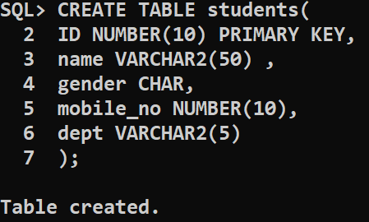

. By using insert command we can insert values in a tables

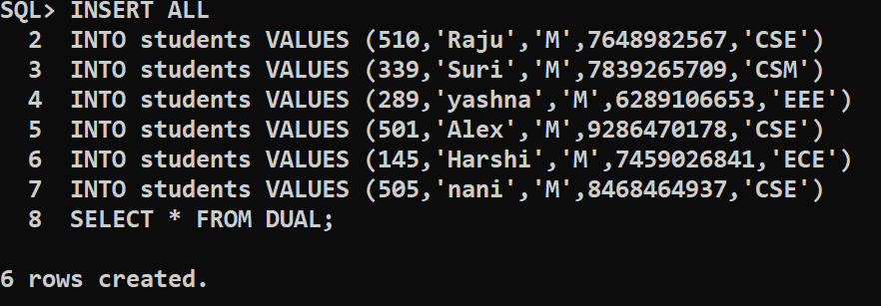

**Creating view :**

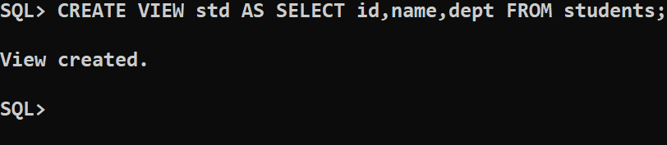

Inserting values :

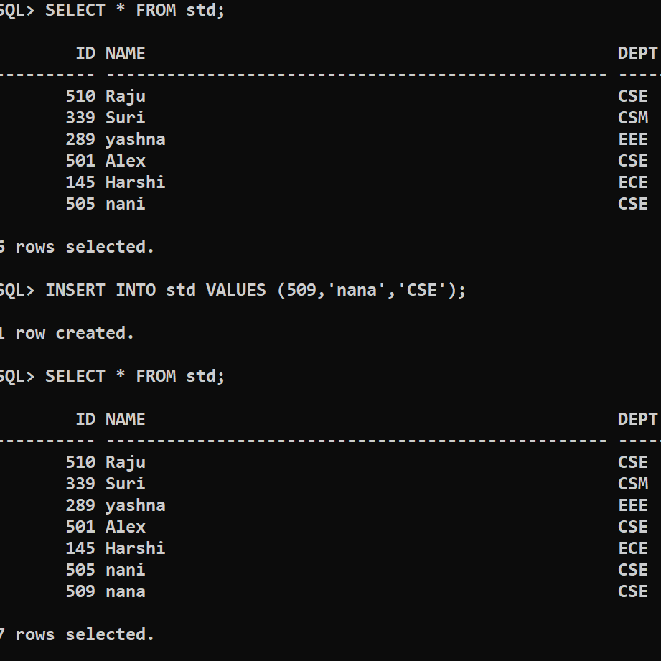

Selecting specific row :

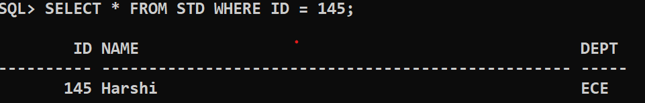

**Update :**

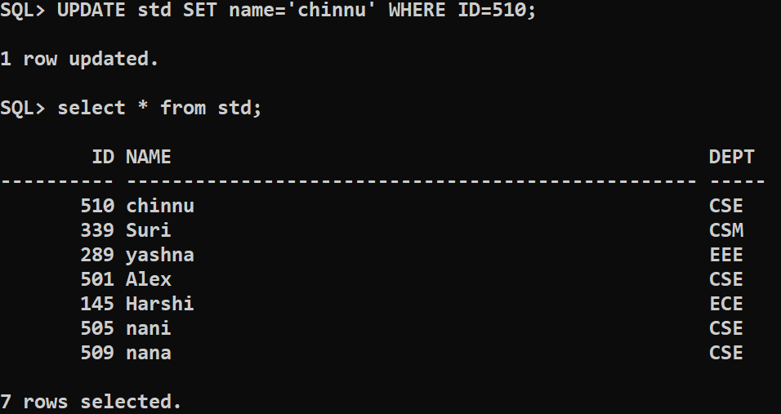**truncate or drop view:**

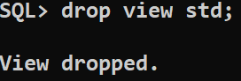

**CONCLUSION :** To implement a view level design using CREATE VIEW,ALTER VIEW ,DELETE VIEW and DROP VIEW IS SUCCESSFULLY EXECUTED